**Lesson Plan – Creating Blocks**

**Learning objectives -**

1. **Revise concepts of libraries, class, objects, dictionaries and lists from previous class**
2. **Creating the default constructor for the block class in our block chain**
3. **Understand the concept of block creating**
4. **Know about mining and miners in in terms of blockchain**

**Materials required -**

**repl.it login credentials**

**A quick recap of what is a blockchain**

Blockchain technology is a decentralized, distributed ledger that stores the record of ownership of digital assets. Any data stored on blockchain is unable to be modified making the technology a legitimate disruptor for industries like payments, cybersecurity and healthcare.

**What does Data in a Block contain?**

Some part of the block contains information which is known as data. This data is nothing but information about sender, receiver and how many coins(money) have been transferred.

The block data contents are as below:

* **Block height** : Block height represents the length of the blockchain.
* **Timestamp** : Date and time at which block is mined or created.
* **Mined by** : Information about miner who mined the block.
* **Block reward** : For each block, miners get rewards in terms of fees in form of coins from the sender.
* **Difficulty** : The amount of effort required to mine a block.
* **Total difficulty** : Total difficulty of entire blockchain
* **Size** : Size of block
* **Gas used** : How much energy used for mining this block
* **Gas limit** : Total energy used for all blocks
* **Extra data** : Additional data provided by miner
* **Hash** : Hash code of block
* **Parent hash** : Hash code of previous block
* **StateRoo**t : State of blockchain. It contain all information about entire blockchain
* **Nonce** : It is a value used during mining of the block. Which defined proof of work.

For now this is enough, we will learn more about these in our upcoming classes and it will be filled with lots of fun.

[**https://www.gemini.com/cryptopedia/what-is-block-in-blockchain-bitcoin-block-size**](https://www.gemini.com/cryptopedia/what-is-block-in-blockchain-bitcoin-block-size)

[**https://blogs.sap.com/2019/01/14/what-is-a-block-in-blockchain/**](https://blogs.sap.com/2019/01/14/what-is-a-block-in-blockchain/)

**The Blockchain Network**

Blockchain, sometimes referred to as distributed ledger technology (DLT), makes the history of any digital asset unalterable and transparent through the use of a decentralized network and cryptographic hashing, that we have already seen in our last class.

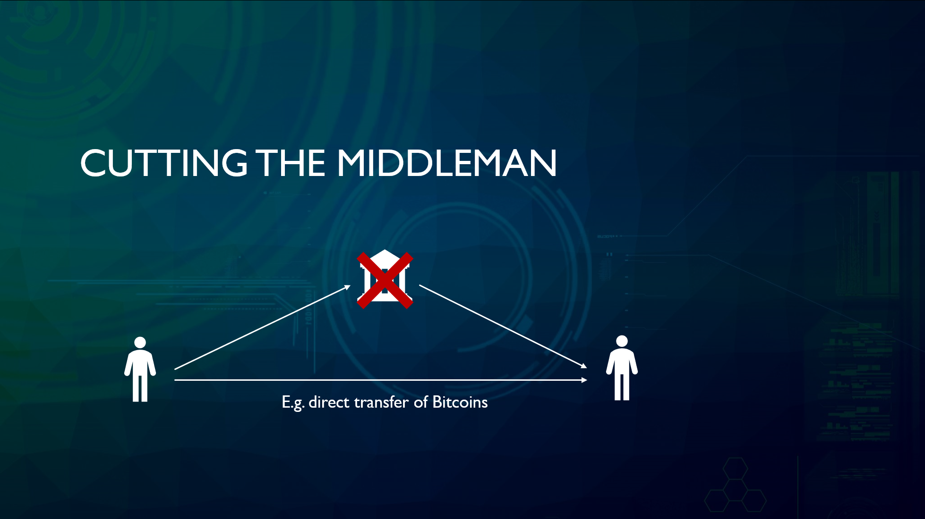

In the blockchain, there are many participants in the network that are constantly checking to ensure that each transaction is valid.

Each participant is a computer that owns a copy of the blockchain and these participants are known as miners. These participants cross-reference their copy of the blockchain each time a new block is being introduced. Because this validation depends on multiple participants, the digital record is “decentralized”.

In order for a new block to be added, 51% of all of the participants in the blockchain network must verify that the new block is not fraudulent. Once a block has been verified as a valid transaction, it is added to each participant’s copy of the blockchain.

By having the majority of miners validate a new transaction, the blockchain removes the need for a central authority and automates the completion of transactions, reducing transaction fees while ensuring a high level of security.



## 

## **Block mining process**

To create a new block, miners must go through a process to solve a math problem. When finding a valid solution for the network, a new block can be taken for granted that will be added to the blockchain by consensus. And for which, the miner who found the solution, will receive a reward for the new block. This reward is known as the block reward.

About every 10 minutes a new block is generated in Bitcoin. So every time one is found, it means the start of mining for another. Whether these are mathematically related or chained together.

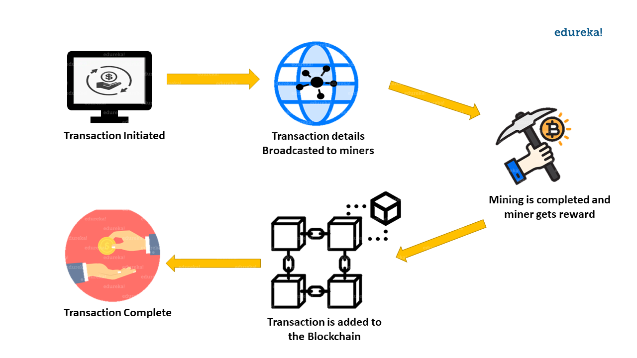

**Creating a block in python**

A block contains transaction data and other important details related to the creation of that block, such as the time when it was created and other unique information. In order to create a block, we must have a record that we wish to store.

**Properties in a Block:**

* **Timestamp:** The time the block is created determines the location of it on the blockchain.
* **Transaction Data:** The information to be securely stored in the block.
* **Hash:** A unique code produced by combining all the contents within the block itself — also known as a digital fingerprint.
* **Previous Hash:** Each block has a reference to the block prior to its hash. This is what makes the blockchain unique because this link will be broken if a block is tampered with, only in a genesis block this data is missing since it is the first block, there is no previous block. Thus the previous hash is empty.

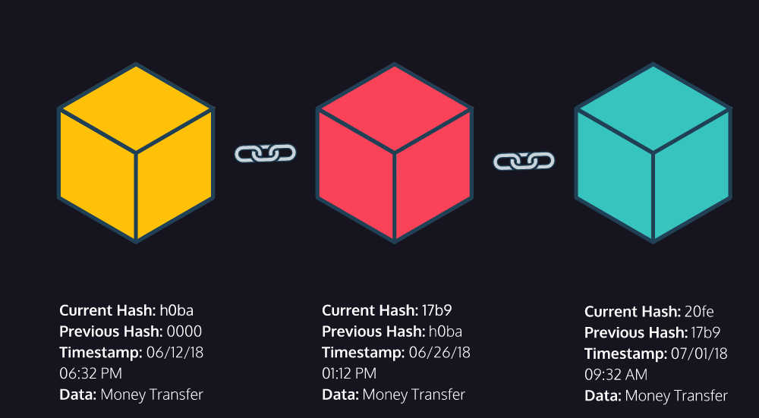

**What exactly is a Genesis Block :**

First block of blockchain is known as the Genesis block. This genesis is very important because from this blockchain starts. Imagine the genesis block is a train engine and the remaining blocks are nothing but the train coach attaching to the engine.

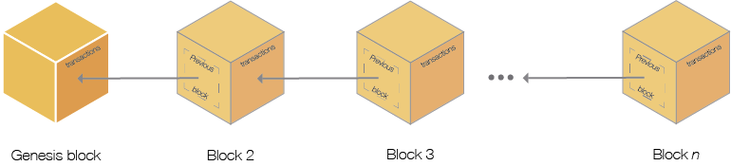

Now let’s think of a way to represent a block in Python. We could create a bigger dictionary and store our data inside this dictionary. But since blocks can be represented as objects, let’s create a Block Class which we can easily use to create new blocks.

**Few key terms before moving ahead**

* **Block** – a collection of data that contains a timestamp and other encrypted information about recent transactions that need to be validated by the network before being added to the chain
* **Nodes** – the computers in a network that maintain full copies of all the transactions, making it virtually impossible to tamper with them
* **Hash** – the alphanumeric string that confirms transactions on the blockchain and serves as a digital footprint
* **Mining** – the process of verifying and adding blocks to a blockchain ledger, as well as adding cryptocurrency coins into circulation using a [proof-of-work](https://www.coindesk.com/learn/2020/12/16/what-is-proof-of-work/) consensus mechanism, Miners create new blocks on the chain through a process called mining.
* **Nonce** – short for "number used only once;" an encrypted number that miners have to solve to verify a new block in the blockchain before closing it
* **Distributed ledger** – a database that is shared and synchronized among members of a decentralized network
* **Block reward** – the incentive mechanism earned by miners that is used to encourage network participation
* **Decentralization:** The concept in which participants work together to validate transactions without relying on a central authority.

**References:**

<https://www.codecademy.com/courses/introduction-to-blockchain/lessons/blockchain-in-python/exercises/transactions>

<https://pynative.com/python-timestamp/>

<https://www.geeksforgeeks.org/python-strftime-function/>

Introducing the lesson/project including the concepts (Time - 45 min)

Link to Repl it Project :

[main.py - Lesson2_Creating_Blocks - Replit](https://replit.com/@JLPythonID/Lesson2CreatingBlocks#main.py)

# %d: returns the day of the month from 1 to 31

# %m: returns the month of the year from 1 to 12

# %Y: return the year in 4-digit format ex,2023

# %B: returns the full name of the month like march,april

# %b: returns the short name of the month like mar,jun

**Homework –**

<https://replit.com/@Bindudevraj/Creating-the-blocks-HW#main.py>